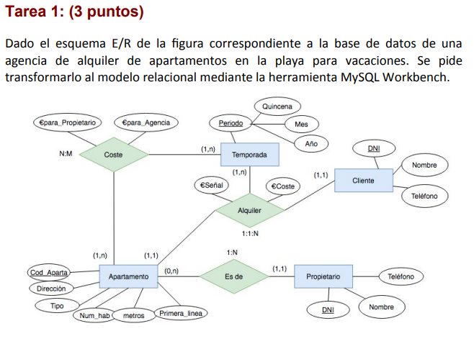
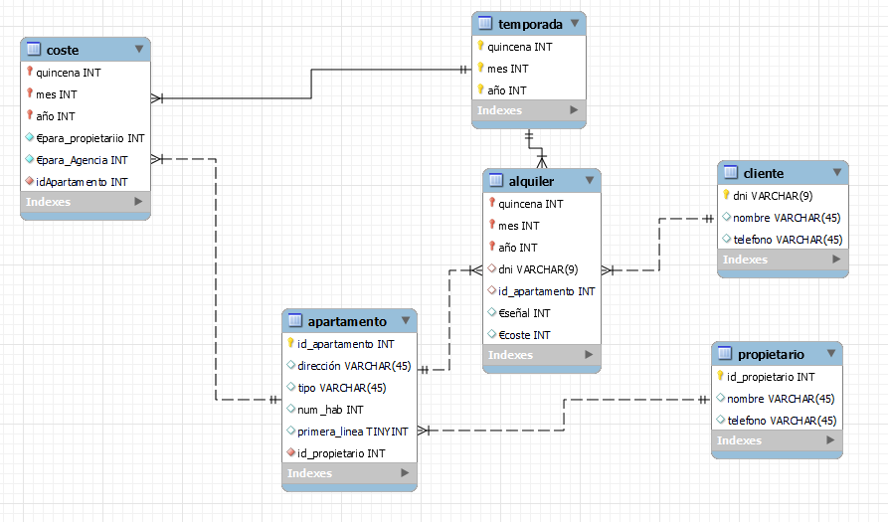

-- MySQL Workbench Forward Engineering

SET @OLD_UNIQUE_CHECKS=@@UNIQUE_CHECKS, UNIQUE_CHECKS=0;
SET @OLD_FOREIGN_KEY_CHECKS=@@FOREIGN_KEY_CHECKS, FOREIGN_KEY_CHECKS=0;
SET @OLD_SQL_MODE=@@SQL_MODE, SQL_MODE='ONLY_FULL_GROUP_BY,STRICT_TRANS_TABLES,NO_ZERO_IN_DATE,NO_ZERO_DATE,ERROR_FOR_DIVISION_BY_ZERO,NO_ENGINE_SUBSTITUTION';

-- -----------------------------------------------------
-- Schema T4P2.1
-- -----------------------------------------------------

-- -----------------------------------------------------
-- Schema T4P2.1
-- -----------------------------------------------------
CREATE SCHEMA IF NOT EXISTS `T4P2.1` DEFAULT CHARACTER SET utf8 ;
USE `T4P2.1` ;

-- -----------------------------------------------------
-- Table `T4P2.1`.`cliente`
-- -----------------------------------------------------
CREATE TABLE IF NOT EXISTS `T4P2.1`.`cliente` (
`dni` VARCHAR(9) NOT NULL,
`nombre` VARCHAR(45) NULL,
`telefono` VARCHAR(45) NULL,
PRIMARY KEY (`dni`))
ENGINE = InnoDB;

-- -----------------------------------------------------
-- Table `T4P2.1`.`propietario`
-- -----------------------------------------------------
CREATE TABLE IF NOT EXISTS `T4P2.1`.`propietario` (
`id_propietario` INT NOT NULL AUTO_INCREMENT,
`nombre` VARCHAR(45) NULL,
`telefono` VARCHAR(45) NULL,
PRIMARY KEY (`id_propietario`))
ENGINE = InnoDB;

-- -----------------------------------------------------
-- Table `T4P2.1`.`apartamento`
-- -----------------------------------------------------
CREATE TABLE IF NOT EXISTS `T4P2.1`.`apartamento` (
`id_apartamento` INT NOT NULL AUTO_INCREMENT,
`dirección` VARCHAR(45) NULL,
`tipo` VARCHAR(45) NULL,
`num_hab` INT NULL,
`primera_linea` TINYINT NULL,
`id_propietario` INT NOT NULL,
PRIMARY KEY (`id_apartamento`),
INDEX `id_propietario` (`id_propietario` ASC) VISIBLE,
CONSTRAINT `propietarioApartamento`
FOREIGN KEY (`id_propietario`)
REFERENCES `T4P2.1`.`propietario` (`id_propietario`)
ON DELETE RESTRICT
ON UPDATE CASCADE)
ENGINE = InnoDB;

-- -----------------------------------------------------
-- Table `T4P2.1`.`temporada`
-- -----------------------------------------------------
CREATE TABLE IF NOT EXISTS `T4P2.1`.`temporada` (
`quincena` INT NOT NULL,
`mes` INT NOT NULL,
`año` INT NOT NULL,
PRIMARY KEY (`quincena`, `mes`, `año`))
ENGINE = InnoDB;

-- -----------------------------------------------------
-- Table `T4P2.1`.`coste`
-- -----------------------------------------------------
CREATE TABLE IF NOT EXISTS `T4P2.1`.`coste` (
`quincena` INT NOT NULL,
`mes` INT NOT NULL,
`año` INT NOT NULL,
`€para_propietariio` INT NOT NULL,
`€para_Agencia` INT NOT NULL,
`idApartamento` INT NOT NULL,
PRIMARY KEY (`quincena`, `mes`, `año`),
INDEX `quincena` (`quincena` ASC) INVISIBLE,
INDEX `mes` (`mes` ASC) INVISIBLE,
INDEX `año` (`año` ASC) INVISIBLE,
INDEX `id_apartamento` (`idApartamento` ASC) VISIBLE,
CONSTRAINT `costeTemporada`
FOREIGN KEY (`quincena` , `mes` , `año`)
REFERENCES `T4P2.1`.`temporada` (`quincena` , `mes` , `año`)
ON DELETE RESTRICT
ON UPDATE CASCADE,
CONSTRAINT `costeApartamento`
FOREIGN KEY (`idApartamento`)
REFERENCES `T4P2.1`.`apartamento` (`id_apartamento`)
ON DELETE RESTRICT
ON UPDATE CASCADE)
ENGINE = InnoDB;

-- -----------------------------------------------------
-- Table `T4P2.1`.`alquiler`
-- -----------------------------------------------------
CREATE TABLE IF NOT EXISTS `T4P2.1`.`alquiler` (
`quincena` INT NOT NULL,
`mes` INT NOT NULL,
`año` INT NOT NULL,
`dni` VARCHAR(9) NULL,
`id_apartamento` INT NULL,
`€señal` INT NULL,
`€coste` INT NULL,
PRIMARY KEY (`quincena`, `mes`, `año`),
INDEX `quincena` (`quincena` ASC) INVISIBLE,
INDEX `mes` (`mes` ASC) INVISIBLE,
INDEX `año` (`año` ASC) INVISIBLE,
INDEX `dni` (`dni` ASC) INVISIBLE,
INDEX `id_apartamento` (`id_apartamento` ASC) VISIBLE,
CONSTRAINT `alquilerTemporada`
FOREIGN KEY (`quincena` , `mes` , `año`)
REFERENCES `T4P2.1`.`temporada` (`quincena` , `mes` , `año`)
ON DELETE RESTRICT
ON UPDATE CASCADE,
CONSTRAINT `alquilerCliente`
FOREIGN KEY (`dni`)
REFERENCES `T4P2.1`.`cliente` (`dni`)
ON DELETE RESTRICT
ON UPDATE CASCADE,
CONSTRAINT `alquilerApartamento`
FOREIGN KEY (`id_apartamento`)
REFERENCES `T4P2.1`.`apartamento` (`id_apartamento`)
ON DELETE RESTRICT
ON UPDATE CASCADE)
ENGINE = InnoDB;

SET SQL_MODE=@OLD_SQL_MODE;
SET FOREIGN_KEY_CHECKS=@OLD_FOREIGN_KEY_CHECKS;
SET UNIQUE_CHECKS=@OLD_UNIQUE_CHECKS;
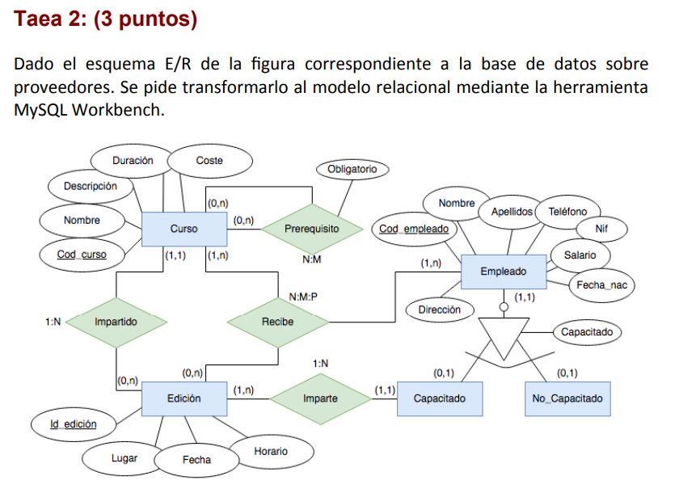
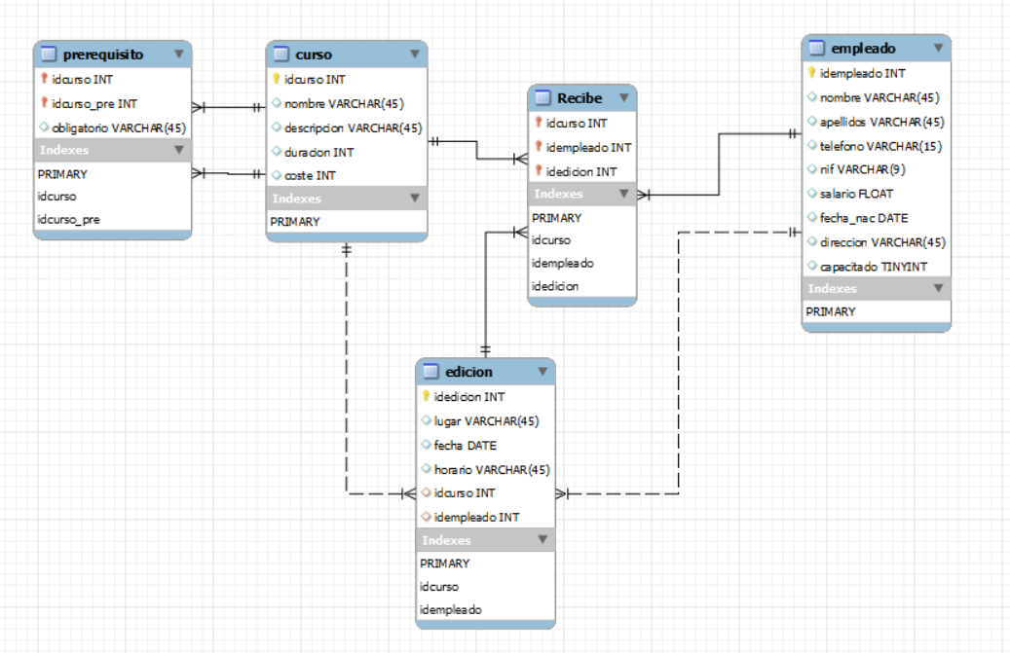
-- MySQL Workbench Forward Engineering
SET @OLD_UNIQUE_CHECKS=@@UNIQUE_CHECKS, UNIQUE_CHECKS=0;
SET @OLD_FOREIGN_KEY_CHECKS=@@FOREIGN_KEY_CHECKS, FOREIGN_KEY_CHECKS=0;
SET @OLD_SQL_MODE=@@SQL_MODE, SQL_MODE='ONLY_FULL_GROUP_BY,STRICT_TRANS_TABLES,NO_ZERO_IN_DATE,NO_ZERO_DATE,ERROR_FOR_DIVISION_BY_ZERO,NO_ENGINE_SUBSTITUTION';
-- -----------------------------------------------------
-- Schema T4P2.2
-- -----------------------------------------------------
-- -----------------------------------------------------
-- Schema T4P2.2
-- -----------------------------------------------------
CREATE SCHEMA IF NOT EXISTS `T4P2.2` DEFAULT CHARACTER SET utf8 ;
USE `T4P2.2` ;
-- -----------------------------------------------------
-- Table `T4P2.2`.`curso`
-- -----------------------------------------------------
CREATE TABLE IF NOT EXISTS `T4P2.2`.`curso` (
`idcurso` INT UNSIGNED NOT NULL AUTO_INCREMENT,
`nombre` VARCHAR(45) NULL,
`descripcion` VARCHAR(45) NULL,
`duracion` INT UNSIGNED NULL,
`coste` INT UNSIGNED NULL,
PRIMARY KEY (`idcurso`))
ENGINE = InnoDB;
-- -----------------------------------------------------
-- Table `T4P2.2`.`empleado`
-- -----------------------------------------------------
CREATE TABLE IF NOT EXISTS `T4P2.2`.`empleado` (
`idempleado` INT UNSIGNED NOT NULL,
`nombre` VARCHAR(45) NULL,
`apellidos` VARCHAR(45) NULL,
`telefono` VARCHAR(15) NULL,
`nif` VARCHAR(9) NULL,
`salario` FLOAT NULL,
`fecha_nac` DATE NULL,
`direccion` VARCHAR(45) NULL,
`capacitado` TINYINT NULL,
PRIMARY KEY (`idempleado`))
ENGINE = InnoDB;
-- -----------------------------------------------------
-- Table `T4P2.2`.`edicion`
-- -----------------------------------------------------
CREATE TABLE IF NOT EXISTS `T4P2.2`.`edicion` (
`idedicion` INT UNSIGNED NOT NULL AUTO_INCREMENT,
`lugar` VARCHAR(45) NULL,
`fecha` DATE NULL,
`horario` VARCHAR(45) NULL,
`idcurso` INT UNSIGNED NULL,
`idempleado` INT UNSIGNED NULL,
PRIMARY KEY (`idedicion`),
INDEX `idcurso` (`idcurso` ASC) VISIBLE,
INDEX `idempleado` (`idempleado` ASC) VISIBLE,
CONSTRAINT `edicionCurso`
FOREIGN KEY (`idcurso`)
REFERENCES `T4P2.2`.`curso` (`idcurso`)
ON DELETE RESTRICT
ON UPDATE CASCADE,
CONSTRAINT `edicionEmpleado`
FOREIGN KEY (`idempleado`)
REFERENCES `T4P2.2`.`empleado` (`idempleado`)
ON DELETE NO ACTION
ON UPDATE NO ACTION)
ENGINE = InnoDB;
-- -----------------------------------------------------
-- Table `T4P2.2`.`prerequisito`
-- -----------------------------------------------------
CREATE TABLE IF NOT EXISTS `T4P2.2`.`prerequisito` (
`idcurso` INT UNSIGNED NOT NULL,
`idcurso_pre` INT UNSIGNED NOT NULL,
`obligatorio` VARCHAR(45) NULL,
PRIMARY KEY (`idcurso`, `idcurso_pre`),
INDEX `idcurso` (`idcurso` ASC) INVISIBLE,
INDEX `idcurso_pre` (`idcurso_pre` ASC) VISIBLE,
CONSTRAINT `prerequisitoCurso`
FOREIGN KEY (`idcurso`)
REFERENCES `T4P2.2`.`curso` (`idcurso`)
ON DELETE RESTRICT
ON UPDATE CASCADE,
CONSTRAINT `prerequisitoCursoRef`
FOREIGN KEY (`idcurso_pre`)
REFERENCES `T4P2.2`.`curso` (`idcurso`)
ON DELETE RESTRICT
ON UPDATE CASCADE)
ENGINE = InnoDB;
-- -----------------------------------------------------
-- Table `T4P2.2`.`Recibe`
-- -----------------------------------------------------
CREATE TABLE IF NOT EXISTS `T4P2.2`.`Recibe` (
`idcurso` INT UNSIGNED NOT NULL,
`idempleado` INT UNSIGNED NOT NULL,
`idedicion` INT UNSIGNED NOT NULL,
PRIMARY KEY (`idcurso`, `idempleado`, `idedicion`),
INDEX `idcurso` (`idcurso` ASC) INVISIBLE,
INDEX `idempleado` (`idempleado` ASC) INVISIBLE,
INDEX `idedicion` (`idedicion` ASC) VISIBLE,
CONSTRAINT `recibeCurso`
FOREIGN KEY (`idcurso`)
REFERENCES `T4P2.2`.`curso` (`idcurso`)
ON DELETE RESTRICT
ON UPDATE CASCADE,
CONSTRAINT `recibeEmpleado`
FOREIGN KEY (`idempleado`)
REFERENCES `T4P2.2`.`empleado` (`idempleado`)
ON DELETE RESTRICT
ON UPDATE CASCADE,
CONSTRAINT `recibeEdicion`
FOREIGN KEY (`idedicion`)
REFERENCES `T4P2.2`.`edicion` (`idedicion`)
ON DELETE RESTRICT
ON UPDATE CASCADE)
ENGINE = InnoDB;
SET SQL_MODE=@OLD_SQL_MODE;
SET FOREIGN_KEY_CHECKS=@OLD_FOREIGN_KEY_CHECKS;
SET UNIQUE_CHECKS=@OLD_UNIQUE_CHECKS;
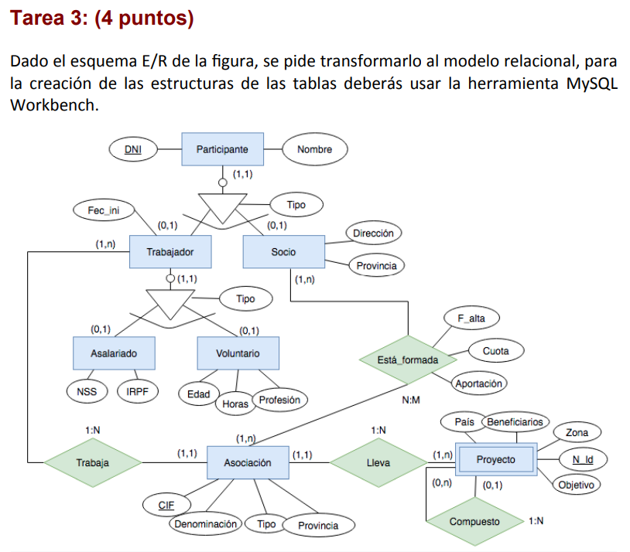
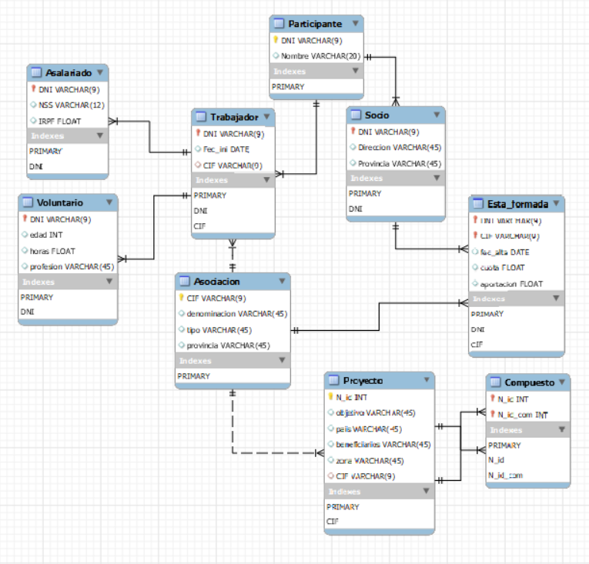
-- MySQL Workbench Forward Engineering
SET @OLD_UNIQUE_CHECKS=@@UNIQUE_CHECKS, UNIQUE_CHECKS=0;
SET @OLD_FOREIGN_KEY_CHECKS=@@FOREIGN_KEY_CHECKS, FOREIGN_KEY_CHECKS=0;
SET @OLD_SQL_MODE=@@SQL_MODE, SQL_MODE='ONLY_FULL_GROUP_BY,STRICT_TRANS_TABLES,NO_ZERO_IN_DATE,NO_ZERO_DATE,ERROR_FOR_DIVISION_BY_ZERO,NO_ENGINE_SUBSTITUTION';
-- -----------------------------------------------------
-- Schema T4P2.3
-- -----------------------------------------------------
-- -----------------------------------------------------
-- Schema T4P2.3
-- -----------------------------------------------------
CREATE SCHEMA IF NOT EXISTS `T4P2.3` DEFAULT CHARACTER SET utf8 ;
USE `T4P2.3` ;
-- -----------------------------------------------------
-- Table `T4P2.3`.`Participante`
-- -----------------------------------------------------
CREATE TABLE IF NOT EXISTS `T4P2.3`.`Participante` (
`DNI` VARCHAR(9) NOT NULL,
`Nombre` VARCHAR(20) NULL,
PRIMARY KEY (`DNI`))
ENGINE = InnoDB;
-- -----------------------------------------------------
-- Table `T4P2.3`.`Asociacion`
-- -----------------------------------------------------
CREATE TABLE IF NOT EXISTS `T4P2.3`.`Asociacion` (
`CIF` VARCHAR(9) NOT NULL,
`denominacion` VARCHAR(45) NULL,
`tipo` VARCHAR(45) NULL,
`provincia` VARCHAR(45) NULL,
PRIMARY KEY (`CIF`))
ENGINE = InnoDB;
-- -----------------------------------------------------
-- Table `T4P2.3`.`Trabajador`
-- -----------------------------------------------------
CREATE TABLE IF NOT EXISTS `T4P2.3`.`Trabajador` (
`DNI` VARCHAR(9) NOT NULL,
`Fec_ini` DATE NULL,
`CIF` VARCHAR(9) NULL,
PRIMARY KEY (`DNI`),
INDEX `DNI` (`DNI` ASC) VISIBLE,
INDEX `CIF` (`CIF` ASC) VISIBLE,
CONSTRAINT `ParticipanteTrabajador`
FOREIGN KEY (`DNI`)
REFERENCES `T4P2.3`.`Participante` (`DNI`)
ON DELETE RESTRICT
ON UPDATE CASCADE,
CONSTRAINT `TrabajadorAsociacion`
FOREIGN KEY (`CIF`)
REFERENCES `T4P2.3`.`Asociacion` (`CIF`)
ON DELETE RESTRICT
ON UPDATE CASCADE)
ENGINE = InnoDB;
-- -----------------------------------------------------
-- Table `T4P2.3`.`Socio`
-- -----------------------------------------------------
CREATE TABLE IF NOT EXISTS `T4P2.3`.`Socio` (
`DNI` VARCHAR(9) NOT NULL,
`Direccion` VARCHAR(45) NULL,
`Provincia` VARCHAR(45) NULL,
PRIMARY KEY (`DNI`),
INDEX `DNI` (`DNI` ASC) VISIBLE,
CONSTRAINT `ParticipanteSocio`
FOREIGN KEY (`DNI`)
REFERENCES `T4P2.3`.`Participante` (`DNI`)
ON DELETE RESTRICT
ON UPDATE CASCADE)
ENGINE = InnoDB;
-- -----------------------------------------------------
-- Table `T4P2.3`.`Asalariado`
-- -----------------------------------------------------
CREATE TABLE IF NOT EXISTS `T4P2.3`.`Asalariado` (
`DNI` VARCHAR(9) NOT NULL,
`NSS` VARCHAR(12) NULL,
`IRPF` FLOAT NULL,
PRIMARY KEY (`DNI`),
INDEX `DNI` (`DNI` ASC) VISIBLE,
CONSTRAINT `TrabajadorAsalariado`
FOREIGN KEY (`DNI`)
REFERENCES `T4P2.3`.`Trabajador` (`DNI`)
ON DELETE RESTRICT
ON UPDATE CASCADE)
ENGINE = InnoDB;
-- -----------------------------------------------------
-- Table `T4P2.3`.`Voluntario`
-- -----------------------------------------------------
CREATE TABLE IF NOT EXISTS `T4P2.3`.`Voluntario` (
`DNI` VARCHAR(9) NOT NULL,
`edad` INT NULL,
`horas` FLOAT NULL,
`profesion` VARCHAR(45) NULL,
PRIMARY KEY (`DNI`),
INDEX `DNI` (`DNI` ASC) VISIBLE,
CONSTRAINT `TrabajadorVoluntario`
FOREIGN KEY (`DNI`)
REFERENCES `T4P2.3`.`Trabajador` (`DNI`)
ON DELETE RESTRICT
ON UPDATE CASCADE)
ENGINE = InnoDB;
-- -----------------------------------------------------
-- Table `T4P2.3`.`Proyecto`
-- -----------------------------------------------------
CREATE TABLE IF NOT EXISTS `T4P2.3`.`Proyecto` (
`N_id` INT NOT NULL,
`objetivo` VARCHAR(45) NULL,
`pais` VARCHAR(45) NULL,
`beneficiarios` VARCHAR(45) NULL,
`zona` VARCHAR(45) NULL,
`CIF` VARCHAR(9) NULL,
PRIMARY KEY (`N_id`),
INDEX `CIF` (`CIF` ASC) VISIBLE,
CONSTRAINT `CIF_Aso`
FOREIGN KEY (`CIF`)
REFERENCES `T4P2.3`.`Asociacion` (`CIF`)
ON DELETE RESTRICT
ON UPDATE CASCADE)
ENGINE = InnoDB;
-- -----------------------------------------------------
-- Table `T4P2.3`.`Esta_formada`
-- -----------------------------------------------------
CREATE TABLE IF NOT EXISTS `T4P2.3`.`Esta_formada` (
`DNI` VARCHAR(9) NOT NULL,
`CIF` VARCHAR(9) NOT NULL,
`fec_alta` DATE NULL,
`cuota` FLOAT NULL,
`aportacion` FLOAT NULL,
PRIMARY KEY (`DNI`, `CIF`),
INDEX `DNI` (`DNI` ASC) INVISIBLE,
INDEX `CIF` (`CIF` ASC) VISIBLE,
CONSTRAINT `DNI_Socio`
FOREIGN KEY (`DNI`)
REFERENCES `T4P2.3`.`Socio` (`DNI`)
ON DELETE RESTRICT
ON UPDATE CASCADE,
CONSTRAINT `CIF_Asocia`
FOREIGN KEY (`CIF`)
REFERENCES `T4P2.3`.`Asociacion` (`CIF`)
ON DELETE RESTRICT
ON UPDATE CASCADE)
ENGINE = InnoDB;
-- -----------------------------------------------------
-- Table `T4P2.3`.`Compuesto`
-- -----------------------------------------------------
CREATE TABLE IF NOT EXISTS `T4P2.3`.`Compuesto` (
`N_id` INT NOT NULL,
`N_id_com` INT NOT NULL,
PRIMARY KEY (`N_id`, `N_id_com`),
INDEX `N_id` (`N_id` ASC) VISIBLE,
INDEX `N_id_com` (`N_id_com` ASC) INVISIBLE,
CONSTRAINT `N_id`
FOREIGN KEY (`N_id`)
REFERENCES `T4P2.3`.`Proyecto` (`N_id`)
ON DELETE RESTRICT
ON UPDATE CASCADE,
CONSTRAINT `N_id_com`
FOREIGN KEY (`N_id_com`)
REFERENCES `T4P2.3`.`Proyecto` (`N_id`)
ON DELETE RESTRICT
ON UPDATE CASCADE)
ENGINE = InnoDB;
SET SQL_MODE=@OLD_SQL_MODE;
SET FOREIGN_KEY_CHECKS=@OLD_FOREIGN_KEY_CHECKS;
SET UNIQUE_CHECKS=@OLD_UNIQUE_CHECKS;

